Venture capital investments in Poland hit EUR 109 million in Q3 2025
PFR Ventures and Inovo.vc have released a report on the Polish venture capital (VC) market for the third quarter of 2025. The findings reveal that 39 companies secured EU 109 million in funding from 45 investment funds.
In Q3 2025, the Polish venture capital (VC) market saw investments totalling ENG 109 million. Polish and foreign funds channelled this amount into 39 transactions supporting domestic innovative enterprises. The quarterly result slightly outperformed the 2023–2024 average of EUR 100 million, and the cumulative value of financing this year has already exceeded the totals recorded at the end of both previous years.
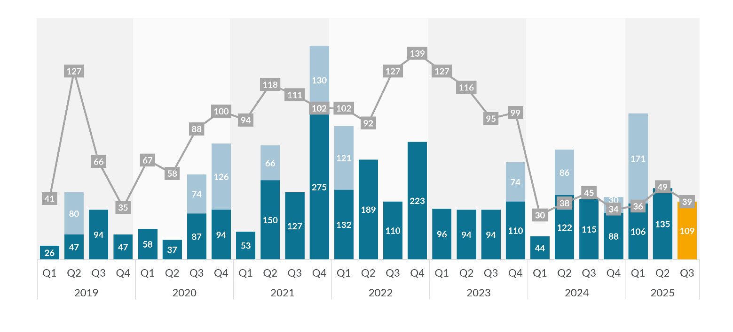
Figure 1 Transaction value. We deliberately present mega-rounds (outliers) separately in the summary, as they distort the statistical picture.
The number of transactions does not differ from the results recorded in 2024, and their average value remains at around EUR 2–3 million. A change has been observed in the number of seed rounds, which has been on an upward trend since the previous quarter (all calculations are based on PLN value). They are being driven, among other things, by a group of new funds capitalised with resources from the European Funds for a Modern Economy (FENG).
‘After the first nine months of this year, we have already surpassed the financing level at which the market plateaued in the previous two years. Funds from the PFR Ventures portfolio accounted for 22 transactions in this quarter – the same number as in Q2 2025. However, compared with 2024, the volume of such transactions has doubled. This change is linked to the launch of EU funding under the FENG programme, which in this quarter supported nine companies,’ said Rozalia Urbanek, Chief Investment Officer at PFR Ventures.
Six investments were recorded at the later stages of company development. The largest closed round was completed by Trasti, which secured EUR 21 million from Triglav and the EBRD. Also notable was Vinci’s investment in ICEYE, the microsatellite manufacturer, which received EUR 9,4 million. Among the standout transactions was sun.store, whose financing was provided by Market One Capital, Movens Capital, and a group of international funds including Contrarian Ventures.
‘The third quarter is traditionally calmer, serving as a warm-up before the busy end of the year. Considering the current pace of investment, and looking at how the final quarter has developed in previous years – both in Poland and across the broader market – we are realistically on course to exceed EUR 0,7 billion in 2025. Poland remains one of the most active VC markets in the region,’ said Karol Lasota, Partner at Inovo.vc.
Investments involving funds from the PFR Ventures portfolio accounted for slightly more than half of all capital invested in innovative Polish enterprises this quarter. Meanwhile, one in every three zlotys invested came from transactions led by foreign funds.
Polish VC funds also remain active abroad, having completed 63 investments this year with a total contribution of approximately EUR 97 million. This represents an increase of more than 10% compared with the record year of 2021.
PFR Ventures is a fund-of-funds management company that invests in venture capital and private equity funds alongside private investors, business angels, and corporations. Its mission is to channel this capital into innovative Polish companies at various stages of development. PFR Ventures currently manages a portfolio of over 95 funds, which have made over 950 investments.
Inovo.vc is a venture capital fund investing in the most ambitious entrepreneurs from Poland and Central and Eastern Europe. It invests in early-stage start-ups of up to €4 million, supporting them in building global brands. Over the past decade, Inovo.vc has backed more than 80 entrepreneurs across 35 start-ups, including Booksy, Infermedica, Spacelift, Tidio, and Zowie, and has co-invested with top global VC funds such as Insight Partners, a16z, Gradient Ventures, and Tiger Global. Across its three funds, Inovo.vc manages capital totalling over €160 million.
Media contact:
Maciej Polak
maciej.polak@pfrventures.pl, +48 532 468 292

